Background and Proposed Research
Why is it difficult to determine stellar ages?
One of the hardest characteristics to measure in astronomy and astrophysics is the ages of stars. Stars can live for billions of years with much of this time spent evolving in the main sequence, where stars fuse hydrogen to helium in their cores. This long lifespan makes it extremely difficult to measure the ages of stars directly, most often requiring astronomers to observe characteristics from their spectra or inferred from stellar evolutionary models. This means there is typically a large margin of error when calculating stellar ages due to their immense lifespans. Ages of stars can tell us more about the life of a star or stellar population, the potential for a star to go supernova and what compact remnant it might leave behind after death, and most importantly the history of our universe. Determining the ages can help in the reconstruction of the Milky Way in the field of Galactic Archaeology, in which stellar ages are sought after to study the formation history of our main galactic components, such as disk and halo as well as the chemical evolution of stellar populations and planets.
How can stellar ages be determined?
There are several ways to get the ages of stars such as gyrochronology, in which the rotation period of stars is measured along with parameters such as magnetic field strength and mass ejection to estimate ages, or isochrone fitting where star clusters have their luminosity and temperature measured and are fit to an evolutionary model. However, both approaches have limitations due to the need for particular types of stars, hard to measure quantities such as rotation period, or uncertainties in our current models. Neither of these methods are very effective when it comes to stars on the giant branches of the HR diagram.
However, there is a more effective way to calculate the ages of these giants through asteroseismology. Much like earthquakes allow scientists on earth to probe the interior structure of our planet, asteroseismology provides information about the interior and density structure of the star. Asteroseismology tells us about the interior of these stars through tracking the star quakes or pulsations time duration otherwise called period spacing or oscillations. All stars pulsate, which causes small changes in the brightness of the star. Astronomers observe the oscillation modes by studying the light curve of the star and how it varies with time. One of the most important parameters is the large frequency of these oscillations which can then be used to estimate the masses of red giant stars. Mass is the biggest constraint on age because it determines how rapidly a star progresses through its life span. By combining the measurements of mass with the spectroscopic observations of the temperature and chemical composition of stars, astronomers can estimate the exact ages of the stars [1] [2].
Why are red giant branch (RGB) and red clump (RC) stars of interest?
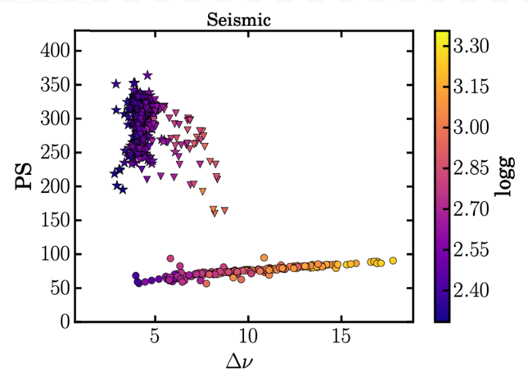
Determining mass and age is only part of the study of stellar structure. To fully understand stellar evolution, especially for red giants, it is also essential to identify the star's precise evolutionary stage. RGB and RC stars are of particular interest due to their difficulty to differentiate the two, but they represent different phases of stellar evolution for a star. Distinguishing RGB and RC stars is important in studying stellar mixing, mass loss, and ages of the stars. The main ways to distinguish the two groups currently is through period spacing measurements obtained through asteroseismology. Period spacing are the time intervals between a star's mixed modes, vibrations that combine the characteristics of sound waves and gravity waves inside the star. These oscillations are important because they tell astronomers about the interior of the star, making period spacing vital to determining the difference between RGB and RC stars due to their vastly different internal structure. Period spacing tells us a star that is burning hydrogen in shells around the core (a RGB star) produces a low period spacing, compared to a star that burns helium in the core (a RC star) that produces a high period spacing. Currently the most accurate way to obtain period spacing measurements is through asteroseismology. This is both a strength and a weakness: we can clearly identify what kind of star we are observing through asteroseismology, but doing seismology on stars requires space missions with extremely high precision equipment that observes the same area of the sky for a long period of time. It is an extremely expensive undertaking and is only applicable for small areas of sky at a time. However, it has been shown that the spectra of a star can also record information about asteroseismic parameters [1]. If we have spectra of stars that also have asteroseismic data, we can then use machine learning tools to link these measurements together. If spectroscopy can inform us about what is happening inside of a star, we can avoid years of expensive space missions.
Figure 1: Period spacing versus dNu from Kepler, highlighting that red giant stars and red clump stars can be separated by their period spacing with asteroseismic parameters [1].
How does TheCannon help compile stellar data?
TheCannon creates a short cut to information usually hidden within a star's core. It is a machine learning tool trained on stars with known seismic labels to recognize subtle spectral signatures, in the CN and CO molecular lines, caused by different internal mixing processes [3]. This in turn allows for stellar classification using only a single spectral snapshot. This is done by TheCannon performing label transfer where it learns the relationship between a star's light and its known physical properties from stars with asteroseismology and then applies the relationship to hundreds to thousands of new stars that only have spectroscopy [1]. This allows for detailed measurements about a star's mass, chemical makeup and age from a single spectral snapshot. This is crucial, as there only exists about a couple of thousand stars with asteroseismic data while millions of spectroscopic data exist, making machine learning tools like TheCannon crucial. In addition, it has been shown that this method is nearly as accurate in distinguishing RGB and RC stars as studies using purely asteroseismic data [1].

Research Question
Period spacing is crucial for determining ages; it is just as important to assist in our understanding of the history of both the Milky Way and our universe. It is extremely difficult to distinguish RGB and RC stars, due to the similarities on the surface of the stars. Without period spacing, these evolutionary states are virtually indistinguishable in spectroscopic data. Although a few thousand stars with period spacing measurements from asteroseismic data while millions of stellar spectra exist, machine learning tools like TheCannon are crucial and enable us to map seismic measurements to spectroscopy. These large data sets contain spectra with various characteristics and labels of stars based on the observational method or survey type. We hypothesize that if we can differentiate RGB and RC stars based on period spacing within an asteroseismic dataset, it can be used as a training set for subsets of spectroscopic data within TheCannon to accurately differentiate stars, with no prior period spacing estimate, from one another. This can then be used to accurately predict the ages of these stars in the red giant branch and the red clump.

Objectives
For this project, the penultimate goal is to train TheCannon on enough data sets with asteroseismic data to get a large, accurate set of stellar spectra with a period spacing label to more accurately distinguish RGB and RC star from one another to then make an age map for our local galactic neighborhood. To do this, the following goals will need to be met:
- Extracting the spectroscopic and asteroseismic data
- Splicing spectroscopic data into subsets to train with TheCannon
- Edition and implementing TheCannon and our gathered subsets to OU supercomputing center for education and research (OSCER) at the University of Oklahoma for more efficient run times for larger data sets
- Along with basic labels (Teff, log(g), [Fe/H]), add further labels such as specific elements abundances to further differentiate stars and retrain the data sets
- Add an period spacing label based off the machine learning outcome to map the different groups of stars

Resources and Methodology
Code gathering and cleaning
To do our project, we require data from multiple sources. First, we need observations of stars from the APOKASC catalog [4]. APOKASC is a database which provides a joint catalog that combines measurements such as temperature and chemical composition from high-resolution infrared spectra from APOGEE-3 catalog (Mathieu Vrard, private communication) [4][5] with astroseismic data measured from the Kepler mission. We then must combine this data with the raw spectra collected from APOGEE-3 to allow us to apply TheCannon. To do this we will use Python to match individual spectra with the APOKASC catalog via the Kepler ID number of the star from both sets. We then select the reference labels that we will use in our analysis (the temperature, chemical composition, surface gravity, period spacing, and mass), along with our observed spectrum, to TheCannon.

Use of TheCannon in code
TheCannon is a machine learning algorithm designed to determine stellar parameters and chemical abundances directly from spectroscopic data without relying on physical models of stellar atmospheres [3]. The algorithm is fast and provides a framework to bring different spectroscopic surveys onto a consistent physical scale ensuring that labels are comparable across different telescopes. TheCannon is trained using a reference data set from APOGEE of stars to learn how spectral flux at every pixel depends on known labels from a small reference set of stars. It makes a generative model to infer labels for a new survey such as the APOKASC-3 catalog. For our purposes, we will use TheCannon to generate a model of how temperature, gravity, chemical composition, mass, and period spacing (from the APOKASC-3) relate to the observed spectra (from APOGEE-3).
Implementation of OSCER
Our label space is relatively small (5 labels) and our initial training set is only a few thousand objects, and the initial steps can be done on a local computer. However, the entire APOGEE3 catalog is quite large and contains millions of stellar spectra and is several terabytes in size. By transitioning over to using a supercomputer allowed us to then run TheCannon with a larger data set than if we continued our local machine.

Proposed Timeline
Deadlines for objectives will be completed based on the following prospective timeline, also shown in Table 1:
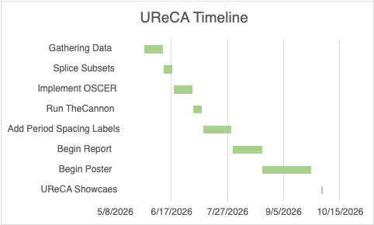
May 29th - Start spectroscopic and asteroseismic data gathering
Table 1: Proposed Timeline for Project
June 12th - Splice subsets with needed labels to train
June 19th - Implement TheCannon in OSCER
July 3rd - Successfully run TheCannon
July 10th - Add labels, including period spacing, to spectra
July 31st - Begin drafting report
August 21st - Finish report, begin poster
September 25th - Complete poster
October 2nd - UReCA showcase

Expected Outcomes/Conclusions
If the research is successful, it will advance how astrophysicists determine ages of red giants and evolution mapping and insight to intergalactic system development. It could potentially be applied to the greater universe on extragalactic star systems to help put constraints on the development of our universe. This would also further tools in understanding galactic archaeology and cosmology.
References
[1] Hawkins, K., Ting, Y.-S., & Walter-Rix, H. 2018, "Photospheric Diagnostics of Core Helium Burning in Giant Stars," The Astrophysical Journal, 853, 20 https://iopscience.iop.org/article/10.3847/1538-4357/aaa08a/pdf

[2] Ness et al. 2016, "Spectroscopic Determination of Masses (and Implied Ages) for Red Giants," The Astrophysical Journal, 823:114 https://iopscience.iop.org/article/10.3847/0004-637X/823/2/114/pdf

[3] Ness et al. 2015, "The Cannon: A Data-Driven Approach to Stellar Label Determination," The Astrophysical Journal, 808:16 https://iopscience.iop.org/article/10.1088/0004-637X/808/1/16/pdf

[4] Abdurro’uf et al. 2022, "The Seventeenth Data Release of the Sloan Digital Sky Surveys: Complete Release of MaNGA, MaStar, and APOGEE-2 Data," The Astrophysical Journal Supplement Series, 259, 35 https://iopscience.iop.org/article/10.3847/1538-4365/ac4414/pdf

[5] Pinsonneault, M. H., et al. 2025, "APOKASC-3: The Third Joint Spectroscopic and Asteroseismic Catalog for Evolved Stars in the Kepler Fields," The Astrophysical Journal Supplement Series, 276, 69 https://iopscience.iop.org/article/10.3847/1538-4365/ad9fef/pdf

